Ecommerce API Architecture

- High-Level Architecture
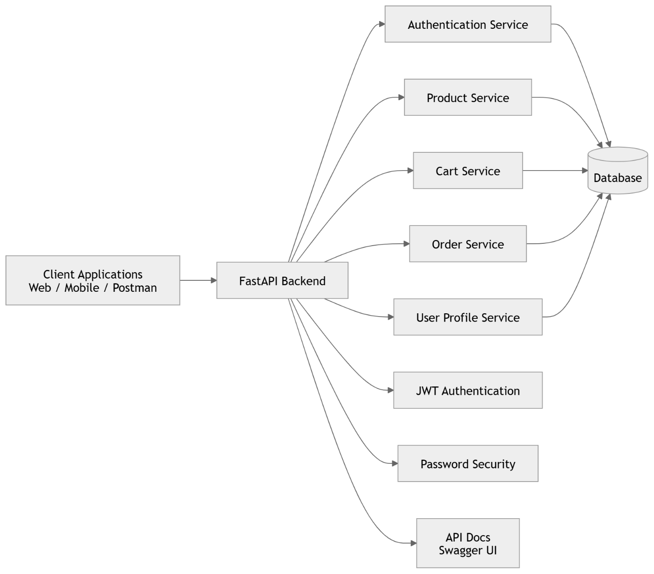

- Architecture Explanation
- Client Layer
The client layer sends HTTP requests to the API.
Examples of clients include:
- Web applications
- Mobile applications
- API testing tools such as Postman
These clients communicate with the backend using REST APIs.

- API Layer
The backend API is built using:
FastAPI
Responsibilities of this layer include:
- Handling incoming requests
- Validating input data
- Managing authentication and authorization
- Returning structured responses
The API also provides automatic documentation using:
Swagger UI

- Service Layer
The service layer contains the business logic of the application.
Authentication Service
Handles:
- User signup
- User login
- Forgot password
- Reset password
Product Service
Handles:
- Add product
- List products
- Update product
- Delete product
Cart Service
Handles:
- Add item to cart
- View cart items
- Update item quantity
- Remove item from cart
Order Service
Handles:
- Create orders
- Retrieve user orders
User Service
Handles:
- User profile management
- Change password

- Security Layer
Security in the application is implemented using:
JWT Authentication
Every protected request must include a valid JWT token for authorization.
Password Hashing
User passwords are securely stored in the database using hashed values.

- Database Layer
The database stores the application's persistent data, including:
- Users
- Products
- Cart items
- Orders
An ORM is used for database interaction:
SQLAlchemy

- Example Request Flow
Example: Add Product
Client
↓
API Route (/products)
↓
Product Service
↓
Database
↓
Response

- Example Workflow
Login Flow
User → Login API
↓
Authentication Service
↓
Password Verification
↓
Generate JWT Token
↓
Return Token to Client

